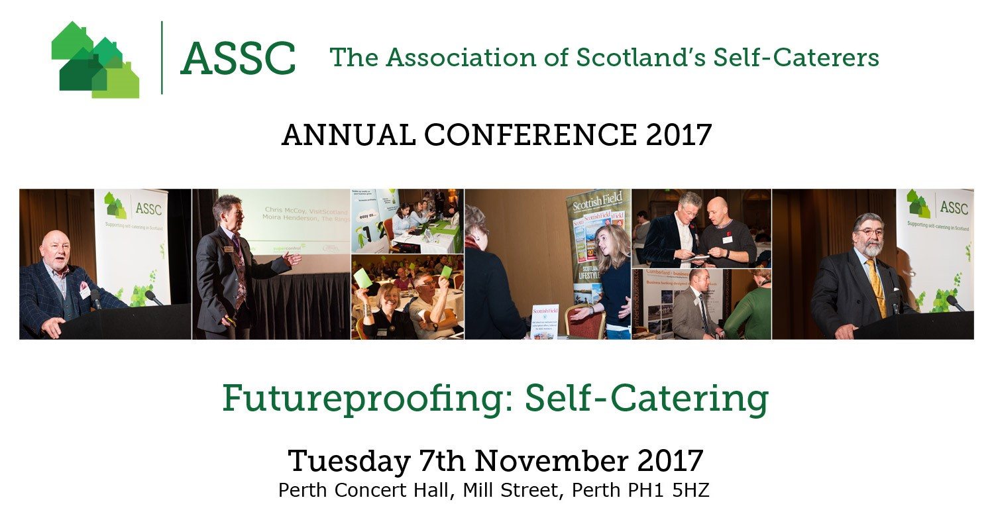

CONFERENCE BOOKING FORM

I wish to book a delegate place at the ASSC Annual Conference 2017 – [NB: The AGM is restricted to ASSC Members only but non-ASSC Members are welcome to attend the Conference]. ASSC invites you join them for a complimentary glass of wine at an informal drinks reception on Monday 6th November 2017 at the The Bothy, 33 Kinnoull Street, Perth PH1 5EN – please indicate if you wish to attend.

How to book
- Book online at www.assc.co.uk/conference/ or via Eventbrite OR complete the form below and email it to Eleanor@assc.co.uk or post to Eleanor McBain, 3 King’s Mount, Baldock, Herts, SG7 6FP to arrive no later than 1st October 2017.
 | First Name | last Name | drinks reception ATTENDANCE
Attendee 1 |  |  | Yes / No
Attendee 2 |  |  | Yes / No
Attendee 3 |  |  | Yes / No

Company / Organisation / Business / Property Name: ___________________________________

Address: _______________________________________________________________________________

City: ____________________________________________________ Postcode: ___________________

Region: ______________________________ Tel No: _______________________________________
Email: _________________________________________________________________________

Member No: _______________

Please indicate any dietary / special requirements: _________________________________________
Delegate Fees
CATEGORY | FEE | NO OF DELEGATES | TOTAL FEES
MEMBER: FULL BOOKING FEE | £70.00 + 20% vat = £84.00 |  | £
MEMBER: EARLY BIRD BOOKING FEE (book by 31st August 2017) | £65.00 + 20% vat = £78.00 |  | £
NON-MEMBER: FULL BOOKING FEE | £92.00 + 20% vat = £110.40 |  | £
NON-MEMBER: EARLY BIRD BOOKING FEE (book by 31st August 2017) | £87.50 + 20% vat = £105.00 |  | £
PARTNER ATTENDANCE: BOOKING FEE – including complimentary attendance at drinks reception | £65.00 + 20% vat = £78.00 |  | £
PARTNER ATTENDANCE – EARLY BIRD BOOKING DISCOUNT - including complimentary attendance at drinks reception | £61.00 + 20% vat = £73.20 |  | £
NB: “Non-member delegates joining the ASSC at or immediately after the conference are eligible for a 15 month membership fee of £90 + VAT per year, with no joining fee - saving you £50 and 3 months complimentary membership”

Payment Options
- Cheque: Payable to The Association of Scotland’s Self-Caterers
- BACS: Association of Scotland’s Self-Caterers Ltd | Sort Code 83-17-05 | Account No: 00643888
- Credit/debit Card:
Credit Card Number: ________________________

Name on Card: __________________________________________________________________

Start Date: _______ Expiry Date: ________ Security code: _______ Issue No: _______

Signature: ___________________________________ Date: _____________________________

Accommodation: is NOT included. See “Accommodation & Parking” document for options.

Payment Terms: Full payment is due on booking / as invoiced. Cancellations must be received in writing be email before Friday 20th October 2017. NO refunds will be made after 20th October 2017. Conference places are transferrable to colleagues, please advise name change as soon as possible.

Data Protection: any personal data supplied will be treated in accordance with the principles of the Data Protection Act 1998. If you do not wish your contact details passed to exhibitors for marketing purposes tick here

VAT will be charged at the current rate applicable at the time of invoice.
CONFIRMATION DETAILS WILL BE SENT TO YOU BY EMAIL

For further information contact our event organiser
Joyce Borthwick
Crescent Events Ltd
Tel: 0131 554 8998
Email: joyce.borthwick@crescentevents.co.uk

